**Report – Web Design CA2**

Group Members :

**Micko Corbantes x00121815**

**Daniel Coxon x00131957**

**Topic** – **A website that reviews and sells the latest computer games.**

We began the design process by thinking about the ease of navigation throughout the pages on the site. We wanted it to be simple for the user and for them not to be overwhelmed by menus and different ways to navigate, our aim was to keep It fluid and obvious and have nothing ambiguous.

We began by going online and looking at different websites and even different genres of websites. This was done so we could get a general idea of what all websites try to achieve for their finished product, and we found that to be ease of use and navigation. We decided that the pages we would need are an ‘index’ (Home page), a ‘Games’ page and a page for each product respectively.

Our main target audience would be gamers of all ages and genders. This is the main reason why we made the site not overly complicated. The site could be used by parents buying games for their children as Christmas/birthday presents so we didn’t want the site to be daunting to use for this audience. The site is suitable for everyone and usable by everyone.

The colours we went for are neutral and plain looking, mainly black and white, we found this to be easy on the eyes. Another reason we did this is because we wanted to use lots of images which make the site vibrant, colourful and alive.

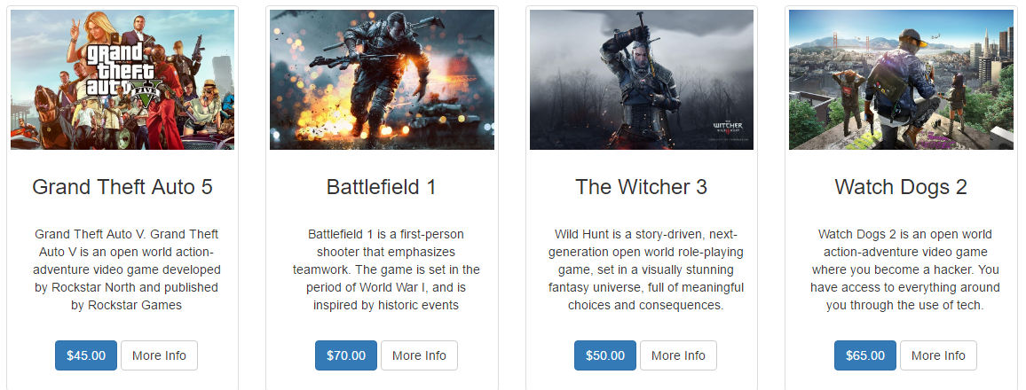

**Our Hierarchical Site Structure: Part 1**

**item**

**item**

**item**

**item**

**Index**

**Products**

**Our Hierarchical Site Structure: Part 2**

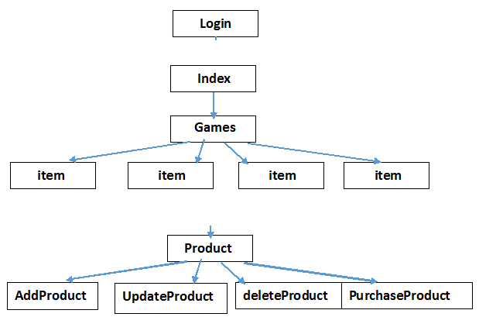

**The Navigation Bar: Part 2:**

**C:\Users\x00131957\Downloads\Capture.PNG**

For the second half of this project we kept the front end of the website mainly the same. We kept the majority of the design the same as we felt that it was easy to navigate and well laid out for the user. The bulk of work we did was on the backend of the website. This included adding the ability to add, update and delete products to a database. Throughout this process there were a few errors that we encountered.

Implementing the login caused the most amount of problems for us. We had the login coded but we were unable to get the properly functionality working correctly. As a result of this we added a “Purchase button” beside the list of products that the user will be linked to after clicking the price of the game in the “Games” page. We are aware that the user should not have access to the create, update and delete functionality in real world situations but unfortunately we found it difficult to get complete functionality seeing we were one member down. Another part we had issues with was the “confirm delete” part. We have the code in and we tried numerous times to get it to work but just couldn’t figure it out.